Kubota Warranty Submission (KUBW): This program allows you to load warranty information from your Service Warranty tickets for editing and final submission to Kubota, directly from the NetView system. Successful submission will result in a Kubota generated claim number for the warranty. NOTE: This program is only available to U.S. Kubota dealers.
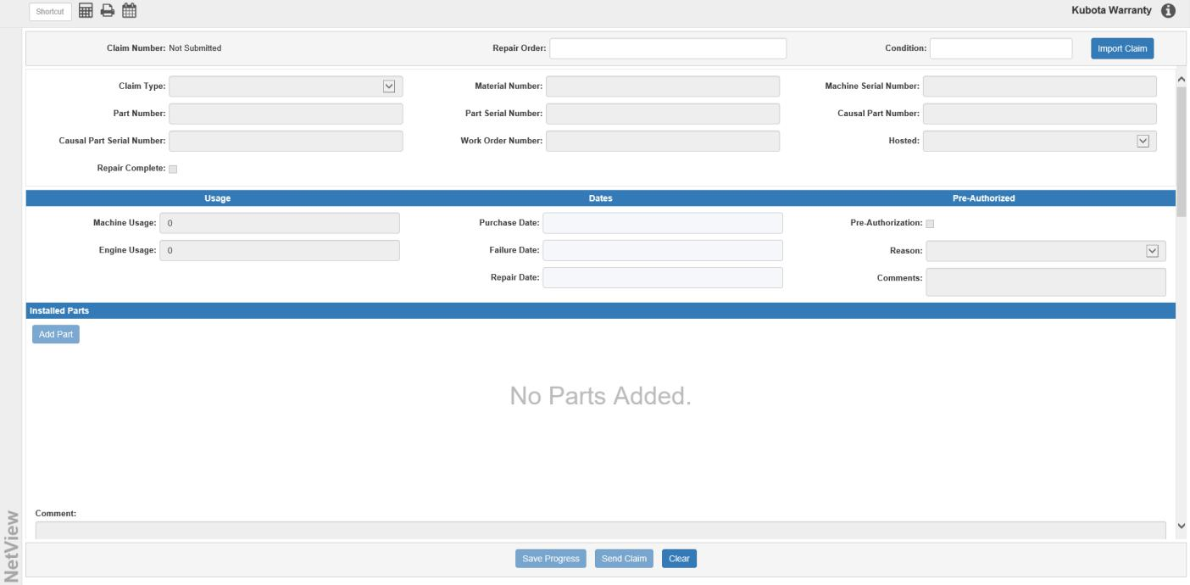

Claim Number: This display field will show the claim number once it is assigned to the claim. Pre-submission, this field will always read “Not Submitted.”

Repair Order: Enter the repair order number for your claim here.

Condition: Enter the condition number on the repair order that relates to the claim here.

NOTE: When you enter these two numbers, the program will check them against all Warranty Repair Orders recorded in Repair Order Maintenace (ROM). If the Repair Order number and the Condition number only match one Warranty RO, that RO’s information will automatically fill in the screen.

Import Claim: If you have a Warranty RO that could be submitted to Kubota already recorded in the system, this button lets you import the RO directly into the system. Click on it to see a list of all Warranty ROs recorded in Repair Order Maintenance (ROM).

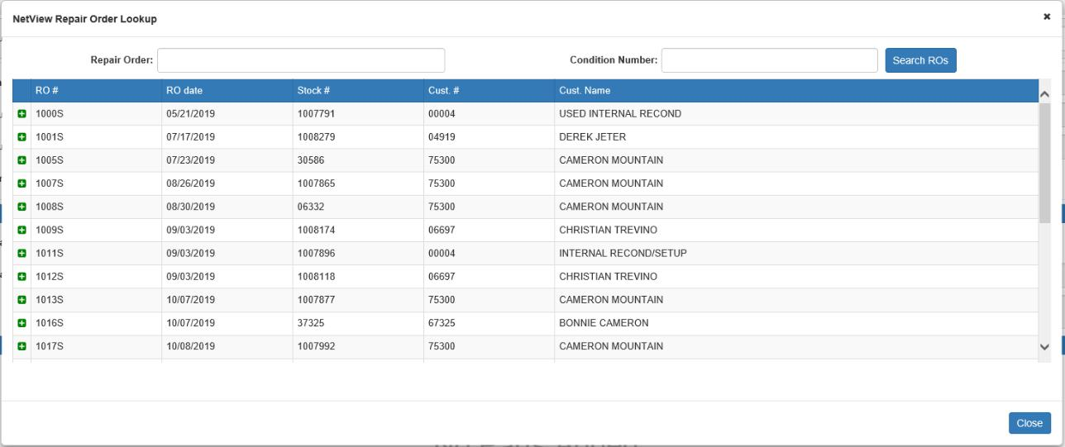

Use the Repair Order and Condition Number fields to look up a particular RO. Click the Expand icon to

the left of the RO to check that the claim has not been submitted, then click the  button to import the claim. This will populate the screen with the relevant RO information.
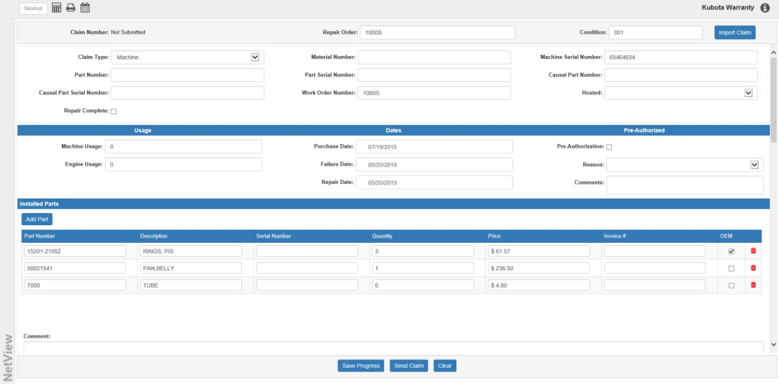

Claim Type: Select the claim type from this menu: Machine or Part.

Material Number: If you are making a Machine claim, enter the machine’s material (model) number here.

Machine Serial Number: If you are making a Machine claim, enter the machine’s serial number here.

Part Number: If you are making a Part claim, enter the part number here.

Part Serial Number: If you are making a Part claim on a serialized part, enter the part’s serial number here.

Causal Part Number: Enter the causal part number for the claim here.

NOTE: Assembly and sub-assembly derived from KPAD for the causal part number provided in the request. If K-Warranty finds multiple entries for a given causal part, K-Warranty will reject the request with a message “The Sub Assembly for this Causal Part cannot be auto-populated, please submit your claim directly in K-Warranty.” and will ask user to file the claim directly in K-Warranty.

Causal Part Serial Number: If the causal part is serialized, enter the causal part’s serial number here.

Work Order Number: Enter the work order number here.

Hosted: Select whether the part is hosted on a machine, and if so, on what kind of machine (OEM or Competitor).

Repair Complete: Check this box if the repair you want to make a claim on is completed. Leave it unchecked if the repair is incomplete.

Usage Fields:

Machine Usage: Enter the machine usage amount here. This field is required, and must be greater than zero (0).

Engine Usage: Enter the engine usage amount here.

Dates Fields:

Purchase Date: Enter the purchase date here. NOTE: This date must be before the Failure Date.

Failure Date: Enter the failure date here. NOTE: This date must be on or before the current date.

Repair Date: Enter the repair date here. NOTE: This date must be on or after the Failure Date.

Pre-Authorized Fields:

Pre-Authorization: Check this box if pre-authorization is required for the claim. Leave it unchecked if pre-authorization is not required.

Reason: If pre-authorization is required, select the pre-authorization reason from this drop-down menu.

Options include:

- Goodwill-Out of Warranty

- Engine Replacement

- High Value

- Verify Coverage

- Goodwill-Other

Comments: If pre-authorization is required, use this field to record comments on the pre-authorization.
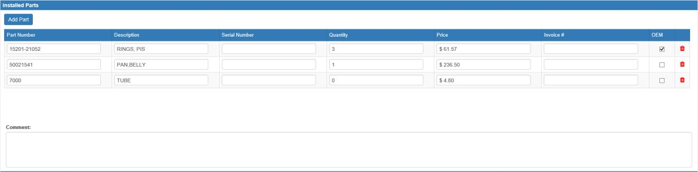

Installed Parts: This section can hold parts installed on the warranty claim unit (if making a Machine claim instead of a Part claim).

Installed Parts Grid Columns:

Part Number: Enter the part number here.

Description: Enter the part’s description here. This field is required if the part is not originally from Kubota.

Serial Number: Enter the part’s serial number here if it is a serialized Kubota part.

Quantity: Enter the part quantity here. If the part is a serialized Kubota part, the quantity should be one (1). Otherwise, the quantity should be greater than zero (0).

Price: Enter the part’s price here. This field is required if the part is not originally from Kubota.

Invoice #: This is an optional field that can hold the part’s invoice number.

OEM: Check this box if the part originally came from Kubota. Leave it unchecked if the part came from a different manufacturer.

Delete: Use this icon to remove an installed part from the grid.

Add Part: To add a new installed part, click this button to create a new line on the grid.

Comment: Use this field to add any comments you may have on the installed parts.
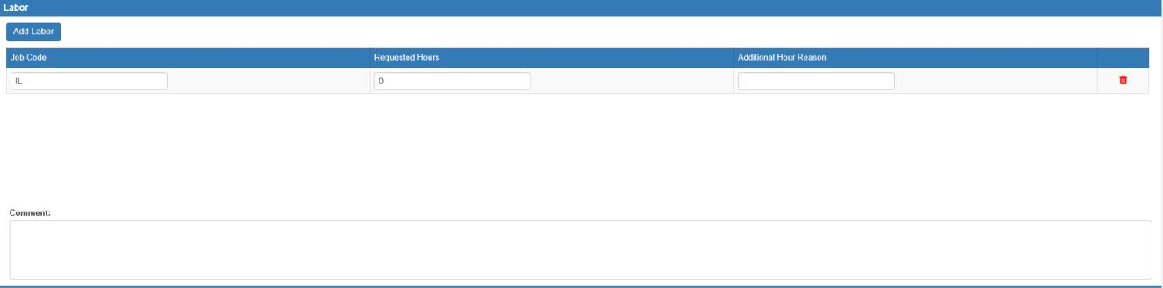

Labor: This section holds any labor requested on the RO.

Labor Grid Columns:

Job Code: Enter the Kubota job code for the labor here. This job code must be valid for the model number entered in the Material Number field, or the claim will be rejected.

Requested Hours: Enter the requested labor hours here.

Additional Hour Reason: If you are requesting more than the standard hours for the job code, you are required to enter the reason why here.

Delete: Use this icon to remove a labor request from the grid.

Add Labor: To add a new labor request, click this button to create a new line on the grid.

Comments: Use this field to add any comments you may have on the labor.
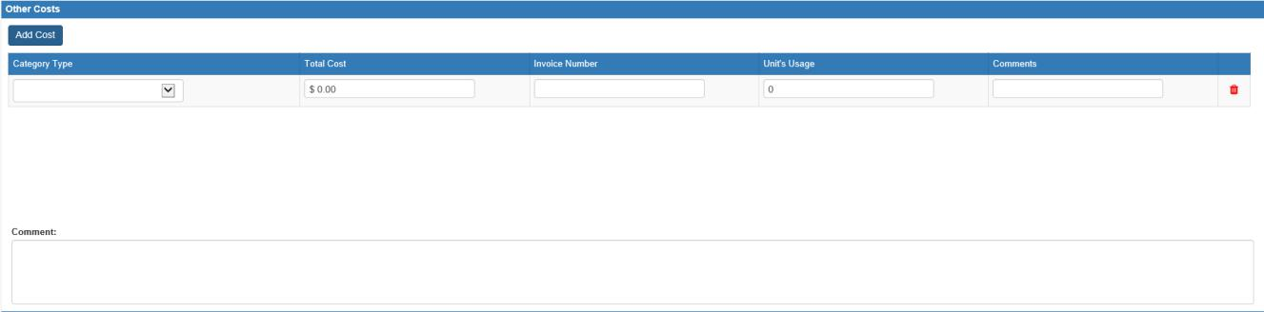

Other Costs: This section holds any other costs for the RO.

Other Costs Grid Columns:

Category Type: Select the other cost category from this drop-down menu. The options are:

- Miscellaneous

- Freight

- Sublet Labor

- EW Parts and Labor Tax

- Hazardous Waste Disposal

- Uptime Assitance

Total Cost: Enter the total dollar amount of the other cost here.

Invoice Number: This is an optional field that can hold the other cost’s invoice number.

Unit’s Usage: Enter the unit’s usage here. This value should be lower than the value in the Machine Usage field.

Comments: This optional field can hold a comment on the particular cost.

Delete: Use this icon to remove a labor request from the grid.

Add Cost: To add a new other cost, click this button to create a new line on the grid.

Comments: Use this field to add any further comments on the other costs that you cannot fit in the individual Comment fields.
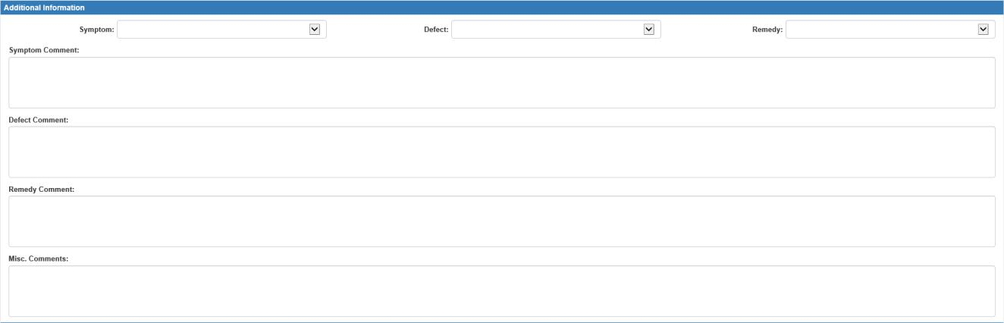

Additional Information:

Symptom: Select a symptom for your claim from the list provided.

Defect: Select the defect for your claim from the list provided.

Remedy: Select the remedy applied/being applied to the defect from the list provided.

Symptom Comment: You can enter a comment on your selected symptom here.

Defect Comment: You can enter a comment on your selected defect here.

Remedy Comment: You can enter a comment on your selected remedy here.

Misc. Comments: If you have any additional comments related to the overall claim, you can enter them here.

Pictures/Attachments to Submit: If you have any images or files you want to submit with your claim, you can attach them here.

Stage Files: Click this button to begin uploading your files. The following window will open:
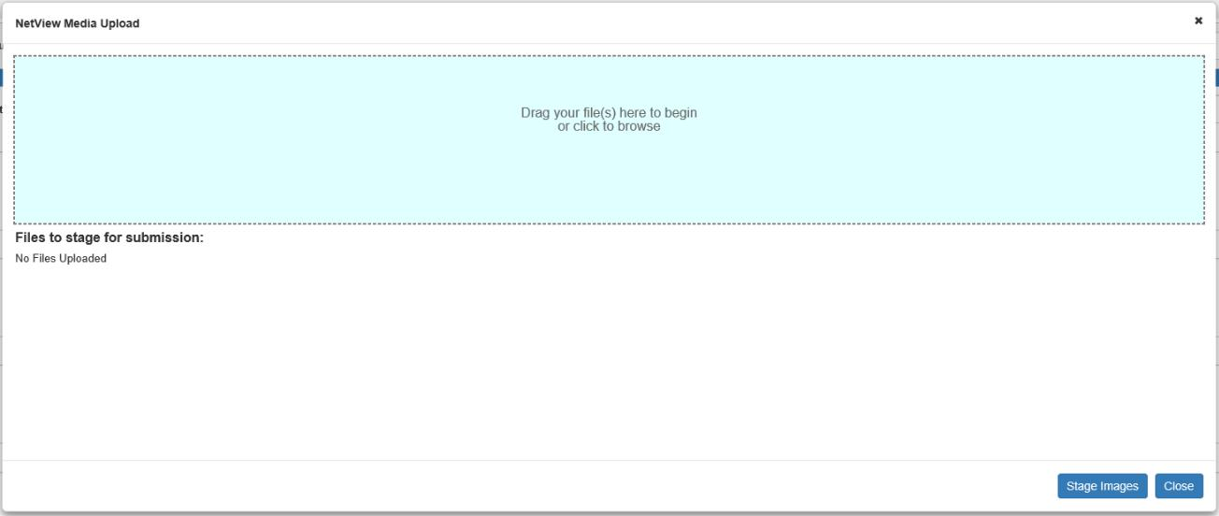

You can either drag the relevant files into the colored space or click the space to browse your computer for the files if you don’t already have them accessible. The added files will then appear under the Files to stage for submission section below. Once you have added all the desired attachments, click Stage Images to close the window and attach the files. If the files are successfully attached, their file names will appear under the Pictures/Attachments to Submit header.

Submit Files: Click this button to actually submit your files to Kubota. NOTE: You can only submit attachments after you submit the actual claim, as you need a claim number to attach the files onto.

Submitted Attachments: Once you successfully submit the files to Kubota, they will appear under this section.


Save Progress: Click this button at any time to save your progress on the claim. NOTE: This will not save any attachments in the Pictures/Attachments to Submit section.

Send Claim: Once your claim is ready, click this button to submit it to Kubota.

Clear: Click this button to clear all fields on the screen except the Repair Order and Condition fields.

